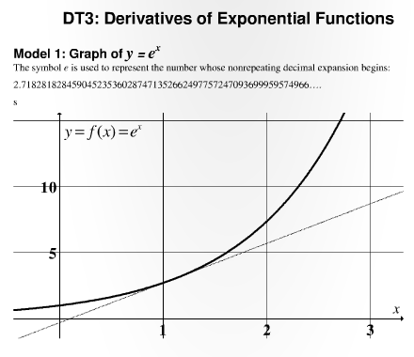
Construct Your Understanding Questions
- According to Model 1, what do the numbers e and π have in common?
- Use the graph of $f\left(x\right)=e^{x}$ in Model 1 to estimate the value of f at x = 1.1

- In Model 1, estimate the slope of the tangent line to the graph of $y=f(x)$ at x = 1.1
- Which question above is asking you to find $f(1.1)$ and which is asking you to find $f^{'}\left(1.1\right)$? Explain your reasoning.

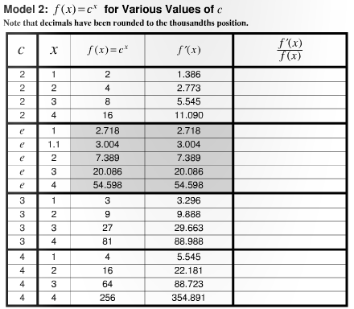
Construct Your Understanding Questions
- Why does it make sense to list $c=e$ on the table after $c=2$ and before $c=3$?
- (Check your work) Are your answers to Questions 2 and 3 consistent with the corresponding table entries?
- Identify the simple pattern in the gray boxes on the table in Model 2. What can you say about the function $f\left(x\right)=e^{x}$ based on this pattern?

- (Check your work) For the generalized function $f\left(x\right)=e^{x}$
  - According to the table in Model 2, it appears that $f\left(x\right)=f'(x)$ when $c=$____
  - Does $f\left(x\right)=f'(x)$ for any of the other values of c listed on the table?

- Fill in the last column in Model 2 (use a calculator if you wish). Round your entries to the thousandths position.
  - (Check your work) Did you find that when $c=2$, $\frac{f^{'}\left(x\right)}{f\left(x\right)}=ln2$?
  - Do other entries in the table (ie, when $c=3$) follow the same pattern? If so, describe this pattern.

- Based on your answer to the previous question, devise an expression for each derivative.
  - For $f\left(x\right)=2^{x}$, what is $f^{'}\left(x\right)=$
  - For $f\left(x\right)=e^{x}$, what is $f^{'}\left(x\right)=$
  - For $f\left(x\right)=3^{x}$, what is $f^{'}\left(x\right)=$
  - For $f\left(x\right)=4^{x}$, what is $f^{'}\left(x\right)=$

- (Check your work) Is your answer to part b of the previous question consistent with the fact that $lne=1$? Explain.

- Write a formula that describes $f^{'}\left(x\right)$ for the function $f\left(x\right)=a^{x}$ for all values of a. Check your answer with at least one other group.

